RAJALAKSHMI ENGINEERING COLLEGE
(An Autonomous Institution)
Rajalakshmi Nagar, Thandalam – 602 105

DEPARTMENT OF COMPUTER SCIENCE AND ENGINEERING
(CYBER SECURITY)
CR23532 – CYBER AND DIGITAL FORENSICS
LABORATORY RECORD

Submitted by : PRITHIKA K

Register Number 241901083
Branch : B.E. Computer Science and Engineering (Cyber Security)
Year / Semester : III Year / V Semester
Academic Year : 2025 – 2026

INDEX
Experiment No. | Title of the Experiment | Date
1 | Study of Computer Forensics and Different Tools Used for Forensic Investigation | 18-07-2026
2 | Introduction to Digital Forensics (TryHackMe) | 18-07-2026
3 | Windows Forensics 1 (TryHackMe) | 23-07-2026
4 | Live Forensics Case Investigation using Autopsy | 30-07-2026
5 | Recover Deleted Files using Forensics Tools | 06-08-2026
6 | Find Last Connected USB on the System (USB Forensics) | 13-08-2026
7 | View Last Activity of Your PC | 20-08-2026
8 | Extraction of Browser Artifacts | 03-09-2026
9 | Comparison of Two Files by Compare It Software | 10-09-2026
10 | Collecting Email Evidence in Victim PC | 17-09-2026
11 | Hiding and Extracting a Text File behind an Image / Audio File using Command Prompt | 24-09-2026
12 | Extraction of EXIF Data from Image Files using ExifReader | 01-10-2026

EXPERIMENT – 1
Study of Computer Forensics and Different Tools Used for Forensic Investigation

Aim
To study the field of computer (digital) forensics and to understand the different tools that are used during a forensic investigation.

Introduction
Digital forensics is the field of determining who was responsible for a digital intrusion or other computer crime. It uses a wide range of techniques to gain attribution to the perpetrator. It relies on the fundamental concept that whenever a digital intrusion or a crime is committed, the perpetrator inadvertently leaves a bit of themselves behind for the investigator to find. These ‘bits’ may be entries in log files, changes to the registry, hacking software, malware or remnants of deleted files, and all of them can provide clues and evidence that help determine the identity of the offender.
Just like hacking, there are a number of software tools for performing digital forensics. Most investigators rely on three major commercial suites – EnCase Forensic (Guidance Software), Forensic Tool Kit or FTK (Access Data) and ProDiscover. These suites are expensive and are mainly used by law enforcement. The same or similar techniques are available in free and open-source suites such as The Sleuth Kit (TSK), Helix and Knoppix, without the polished interface. In addition, a large number of individual tools are available in distributions such as BackTrack and Kali Linux.

Procedure
- The commercial forensic suites used by law enforcement – EnCase Forensic, Forensic Tool Kit (FTK) and ProDiscover – were identified.
- The free and open-source forensic suites were studied – The Sleuth Kit (TSK), Helix and Knoppix.
- The individual forensic tools available in the Kali / BackTrack distribution were listed and their purpose was noted.
- The forensics field tools such as FTK Imager, Log Parser Lizard GUI, Noxcivis Field Toolkit, Active@ Partition Recovery and Autopsy were studied.
The function of each tool identified during the study is summarised in the table below.

Forensic Tools Studied
Tool | Purpose
EnCase Forensic | Commercial forensic suite widely used by law enforcement.
FTK (Forensic Toolkit) | Commercial suite; FTK Imager creates forensically sound disk images.
ProDiscover | Commercial forensic investigation suite.
The Sleuth Kit (TSK) | Open-source collection of command-line forensic tools.
Autopsy | Graphical front-end for The Sleuth Kit; used to investigate disks and images.
FTK Imager | Forensic disk imager, memory capture and file recovery.
Log Parser Lizard GUI | Flexible and powerful log file parser.
Noxcivis Field Toolkit | Collects information from a live computer during incident response.
Active@ Partition Recovery | Recovers deleted and lost partitions.
USBDeview | Lists connected and previously used USB devices.
LastActivityView | Displays a log of recent user actions and system events.
ChromeHistoryView / IECacheView | Reads browser history and cache artifacts.
Compare It | Compares two files and highlights the differences.
DumpIt | Generates a physical memory dump of Windows machines.
Bulk Extractor | Extracts features such as e-mail, URLs and phone numbers from an image.
ExifReader | Extracts EXIF metadata from image files.
Recover My Files | Recovers deleted files from drives and disk images.
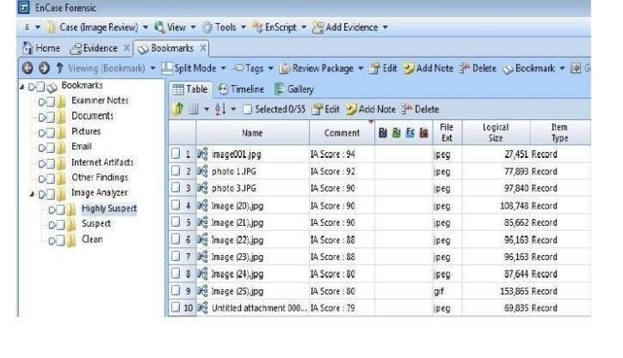
Fig. 1.1 EnCase Forensic – a widely used commercial forensic suite
Timestamp: 12-10-2026, 14:20:15
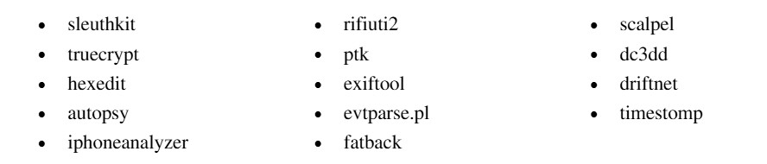
Fig. 1.2 Some of the forensic tools available in the BackTrack / Kali distribution
Timestamp: 12-10-2026, 14:22:41

Result
Thus, the field of computer forensics and the various tools used for forensic investigation were studied successfully, along with their purpose and usage.

EXPERIMENT – 2
Introduction to Digital Forensics (TryHackMe)

Aim
To understand the basics of digital forensics and the standard digital forensics process by completing the TryHackMe room “Intro to Digital Forensics”.

Procedure
- Log in to TryHackMe (tryhackme.com) using an account and open the room “Intro to
Digital Forensics”.
- Study Task 1 – Introduction to Digital Forensics – which defines digital forensics and explains the situations in which it is applied (criminal investigations, corporate incident response, civil cases and so on).
- Study Task 2 – Digital Forensics Process – and note the standard phases followed during an investigation: identification, preservation, collection, examination, analysis and presentation/reporting.
- Work through Task 3 – Practical Example of Digital Forensics – in which a sample scenario is analysed to determine the source of the evidence.
- Answer all the questions in every task; the answers can be verified using the hints provided in the room.
- Confirm that the room displays 100% completion and note the key takeaways of the room.
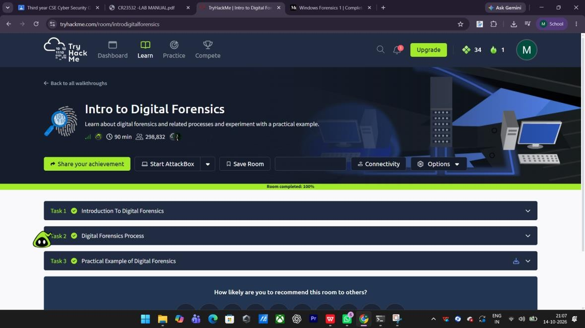
Fig. 2.1 TryHackMe – “Intro to Digital Forensics” room showing 100% completion
Timestamp: 14-10-2026, 21:07:54

Result
The “Intro to Digital Forensics” room was completed with 100% progress. The basic concepts of digital forensics and the standard digital forensics process were understood.

EXPERIMENT – 3
Windows Forensics 1 (TryHackMe)

Aim
To learn Windows registry forensics and to identify important Windows forensic artifacts by completing the TryHackMe room “Windows Forensics 1”.

Procedure
- Log in to TryHackMe and open the room “Windows Forensics 1”.
- Study “Introduction to Windows Forensics” – why Windows is a rich source of evidence and the type of artifacts that it stores.
- Study “Windows Registry and Forensics” – the registry hives (SAM, SYSTEM, SOFTWARE, SECURITY, NTUSER.DAT and USRCLASS.DAT) and the kind of information each hive holds.
- Study “Accessing Registry Hives Offline” – how the hives can be mounted and read from an acquired image using tools such as Registry Explorer.
- Study the “Data Acquisition” section and learn how the relevant hives are collected from a live or dead system.
- Study “Exploring Windows Registry” and “System Information and System Accounts” – hostname, last shutdown time, user accounts and logon information.
- Study “Usage or Knowledge of Files/Folders” and “Evidence of Execution” – recent files, shellbags, Run keys, prefetch files and jump lists.
- Study “External Devices / USB Device Forensics” – the USB connection artifacts that are stored in the registry.
- Complete the hands-on challenge and read the conclusion of the room.
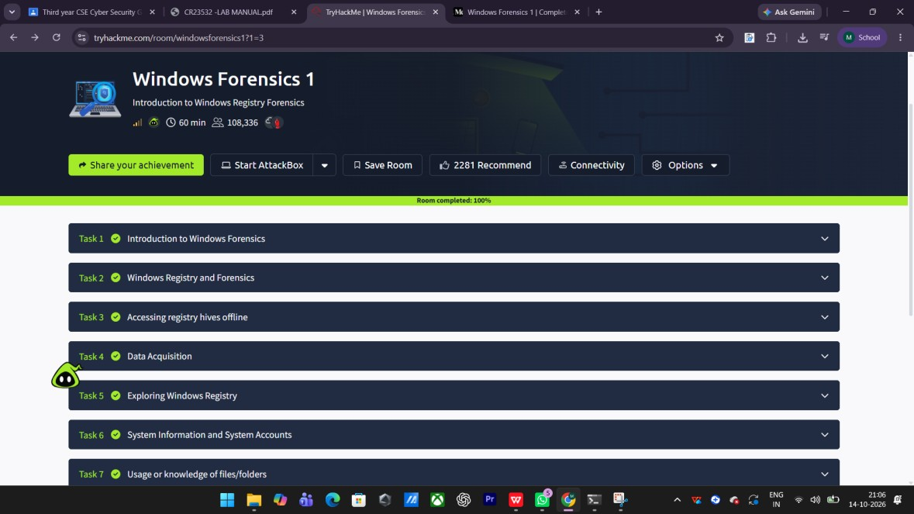
Fig. 3.1 TryHackMe – “Windows Forensics 1” room with the list of tasks
Timestamp: 14-10-2026, 21:06:36
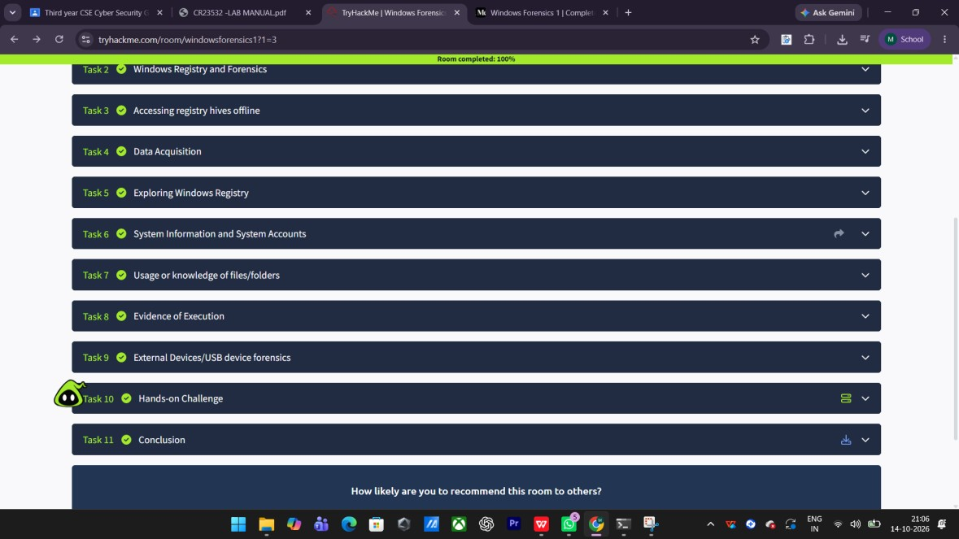
Fig. 3.2 TryHackMe – Windows Registry and Forensics and evidence of execution sections
Timestamp: 14-10-2026, 21:06:50

Result
The “Windows Forensics 1” room was completed successfully. Windows registry hives, evidence of execution, file and folder usage artifacts, and USB device forensics were studied.
EXPERIMENT – 4
Live Forensics Case Investigation using Autopsy

Aim
To perform a live forensic case investigation on a disk image using the Autopsy forensic platform and to generate a forensic report.

Procedure
- Download Autopsy from the official website and install it. Launch the application; the welcome screen is displayed with the ‘New Case’ and ‘Open Case’ options.
- Click on ‘New Case’. Enter the Case Name and choose a Base Directory in which the case database and the report will be stored.
- Enter the case number and the examiner details (name, phone number and e-mail address) and click ‘Finish’ to create the case.
- The Add Data Source wizard opens. In Step 1 select the host, and in Step 2 choose the data source type (Disk Image, Local Disk, Logical Files, Unallocated Space Image File, etc.).
- Browse and select the disk image or drive to be investigated, and set the input time zone (Asia/Calcutta) and the way the image is to be split.
- Configure the ingest modules – all modules (Hash Lookup, File Type Identification, Extension Mismatch Detector, Embedded File Extractor, Picture Analyzer, Email Parser, Encryption Detection, Interesting Files Identifier, PhotoRec Carver, Virtual Machine Extractor, etc.) are selected so that the maximum evidence is extracted.
- Click ‘Finish’. Autopsy processes the data source and adds the results to the local database.
- Once the processing is complete, generate the forensic report from the ‘Generate Report’ option (HTML/Excel report modules can be selected).
- Examine the results – Devices Attached, EXIF Metadata, Installed Programs, Operating System Information, OS User Accounts, Recent Documents, Web Bookmarks, Web Cookies, Web Downloads, Web History, Web Search and E-mail Addresses.
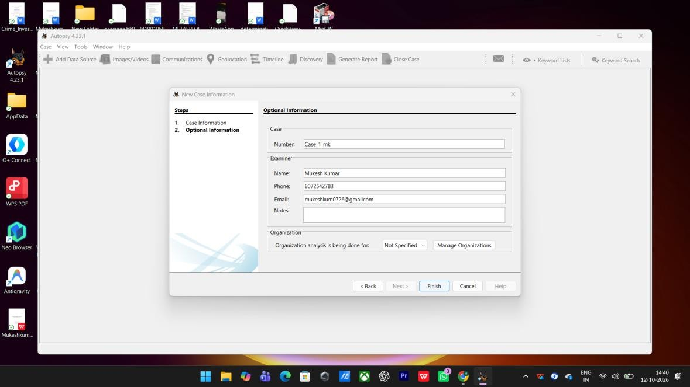
Fig. 4.1 Autopsy – entering the examiner and optional case information
Timestamp: 12-10-2026, 14:40:09
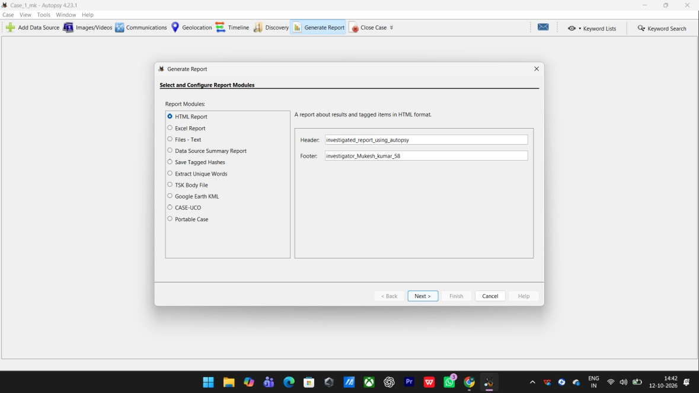
Fig. 4.2 Autopsy – selecting and configuring the report modules Timestamp: 12-10-2026, 14:42:47
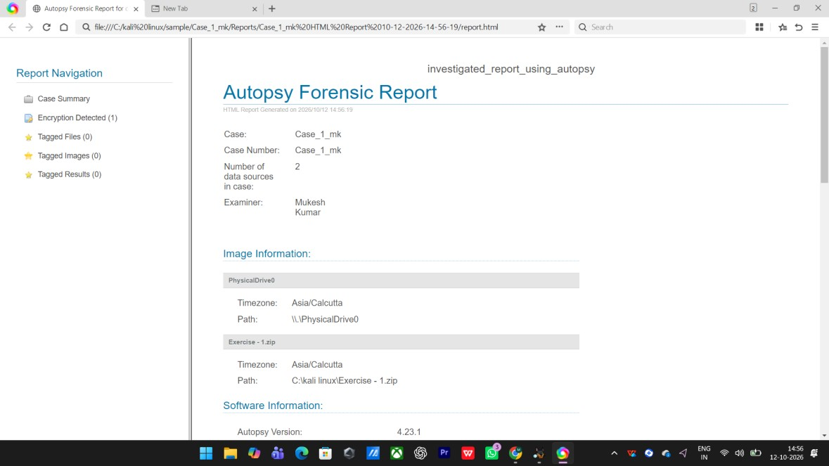
Fig. 4.3 Autopsy forensic report – case summary and data sources
Timestamp: 12-10-2026, 14:56:35
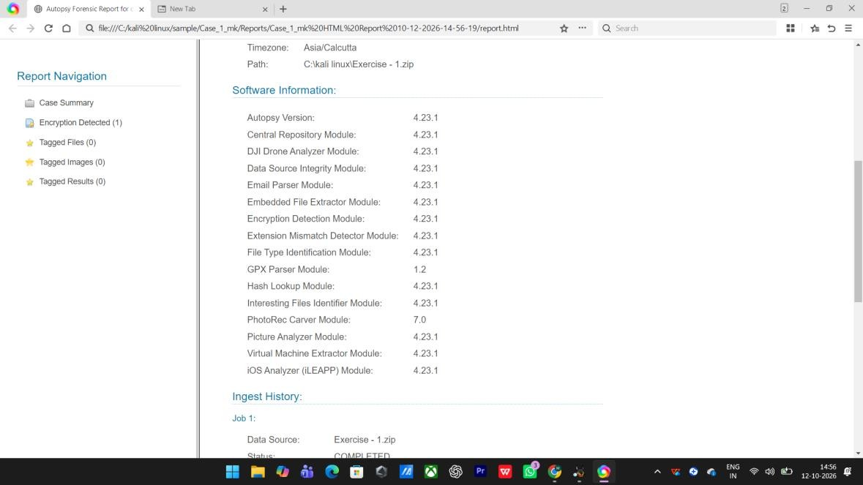
Fig. 4.4 Autopsy report – software information and ingest modules Timestamp: 12-10-2026, 14:56:49
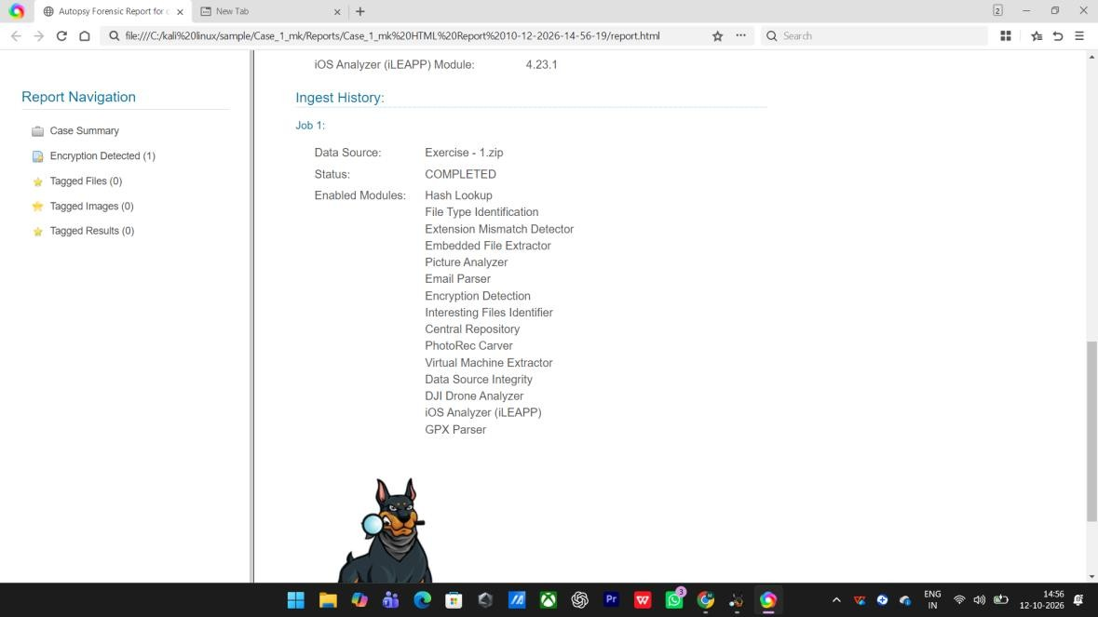
Fig. 4.5 Autopsy report – ingest history and enabled modules
Timestamp: 12-10-2026, 14:57:02
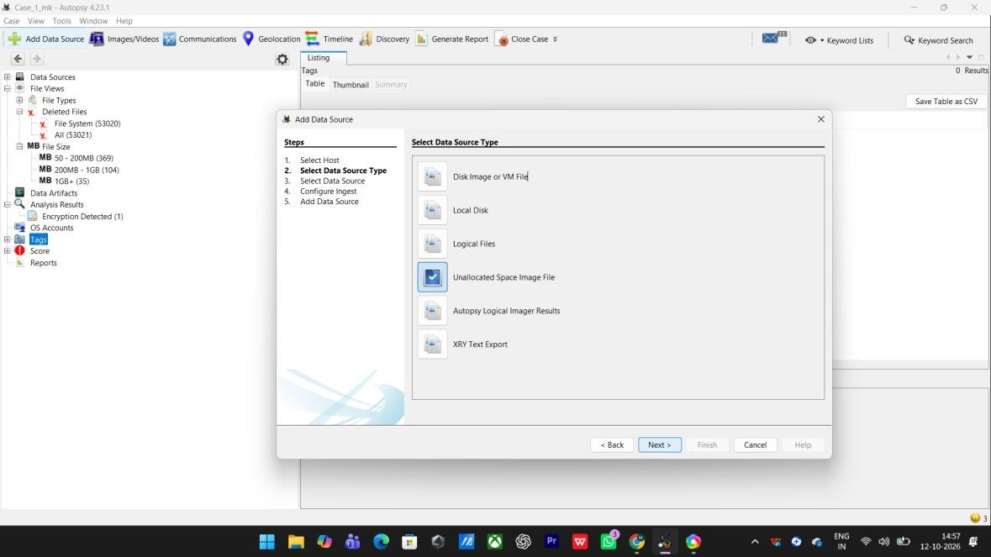
Fig. 4.6 Autopsy – adding a data source (selecting the source type) Timestamp: 12-10-2026, 14:57:58
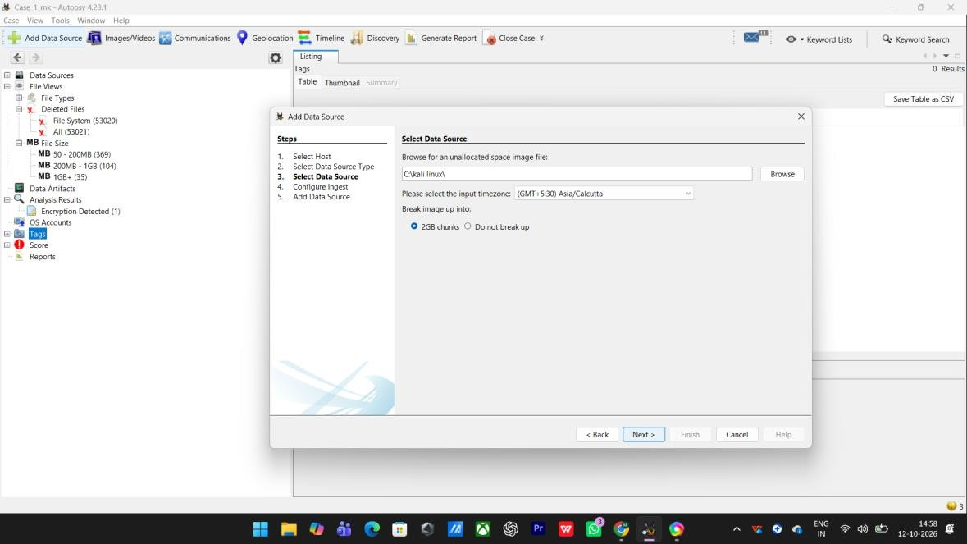
Fig. 4.7 Autopsy – browsing for the disk image and setting the input time zone
Timestamp: 12-10-2026, 14:58:10

Result
Thus, a live forensic case investigation was carried out using Autopsy. The evidence device, the operating system information, user accounts, recent documents and browser artifacts were identified and the forensic report was generated successfully.

EXPERIMENT – 5
Recover Deleted Files using Forensics Tools (FTK Imager)

Aim
To recover a deleted file from a storage device by creating a forensically sound bit-by-bit image using FTK Imager, and to verify the integrity of the image using hash values.

Procedure
- Step 1 (Create the file): Create a sample file ‘malicious.txt’ in Notepad, type some content into it and save it to the drive.
- Step 2 (Delete the file): Delete the file so that it is no longer visible to the user. The data of the deleted file still remains in the unallocated space of the drive until it is overwritten.
- Step 3 (Understand imaging): A deleted file is not copied by an ordinary file copy or backup. Therefore, a forensic investigator first makes a forensically sound bit-by-bit image of the drive.
- Step 4 (Start the imager): Install and open FTK Imager, and select File → Create Disk Image.
- Step 5 (Select the source): In the Select Source dialog, choose the evidence type – Physical Drive (a logical drive or an existing image file can also be selected) – and click
‘Next’.
- Step 6 (Choose the image type): In the Select Destination Image Type dialog, choose the image format – Raw (dd), SMART, E01 or AFF. E01 is preferred because it supports compression and integrity verification.
- Step 7 (Evidence details): Enter the Evidence Item Information – case number, evidence number, unique description, the examiner name and any notes.
- Step 8 (Destination): Specify the Image Destination Folder, the image file name, the fragment size (MB) and the compression level.
- Step 9 (Create the image): Click ‘Start’. FTK Imager begins creating the bit-by-bit image of the drive and shows the progress.
- Step 9 (Verify the image): After the image is created, use File → Verify Drive/Image to compute and compare the MD5 and SHA-1 hash values and confirm that the image is an exact copy of the source.
- Step 10 (Recover the deleted file): Analyse the resulting image so that the deleted file can be recovered (data carving), and compare the recovered content with the original to confirm the recovery.
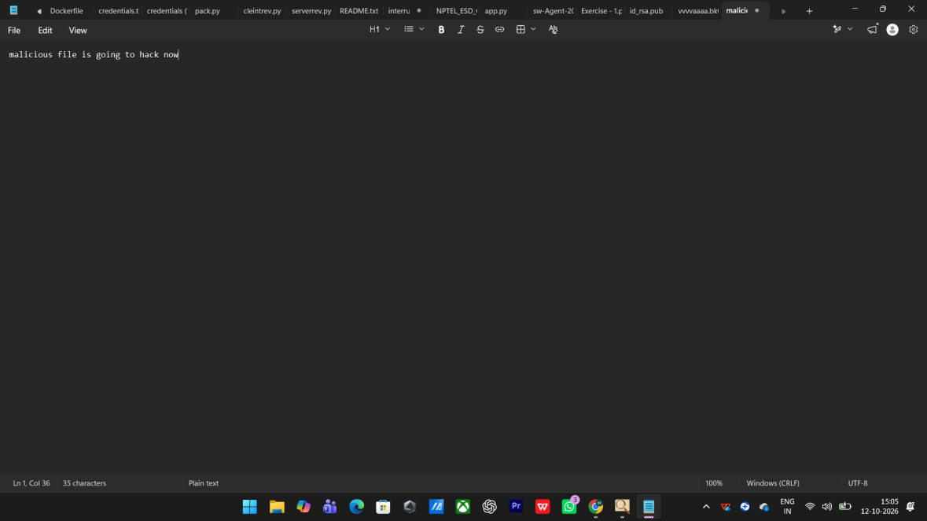
Fig. 5.1 Creating the target file ‘malicious.txt’ with the sample content
Timestamp: 12-10-2026, 15:05:12
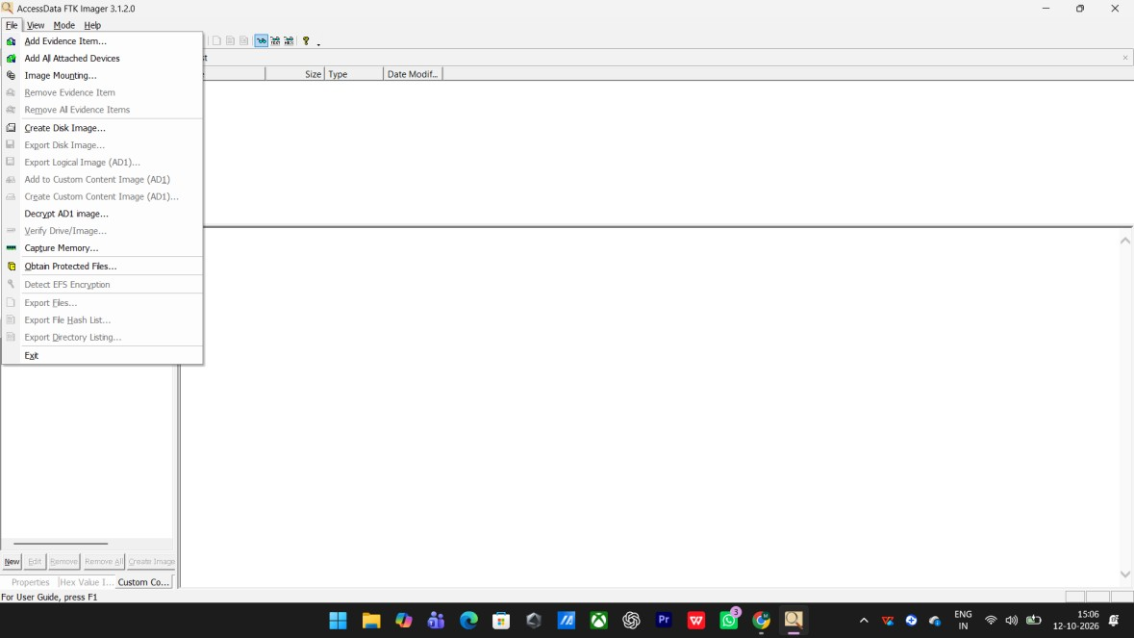
Fig. 5.2 FTK Imager – selecting ‘Create Disk Image’ from the File menu Timestamp: 12-10-2026, 15:06:35
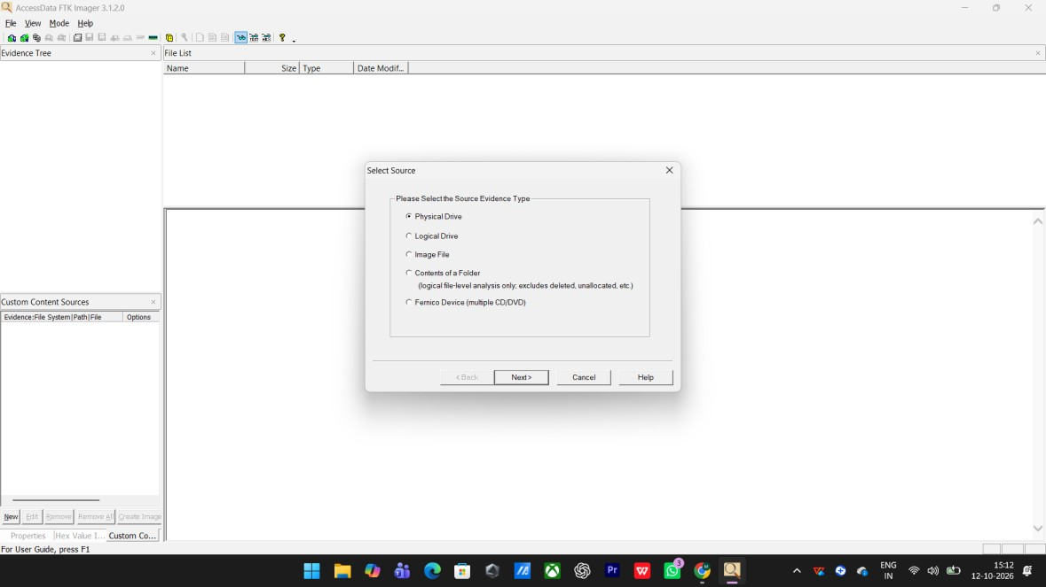
Fig. 5.3 FTK Imager – selecting the source evidence type
Timestamp: 12-10-2026, 15:12:06
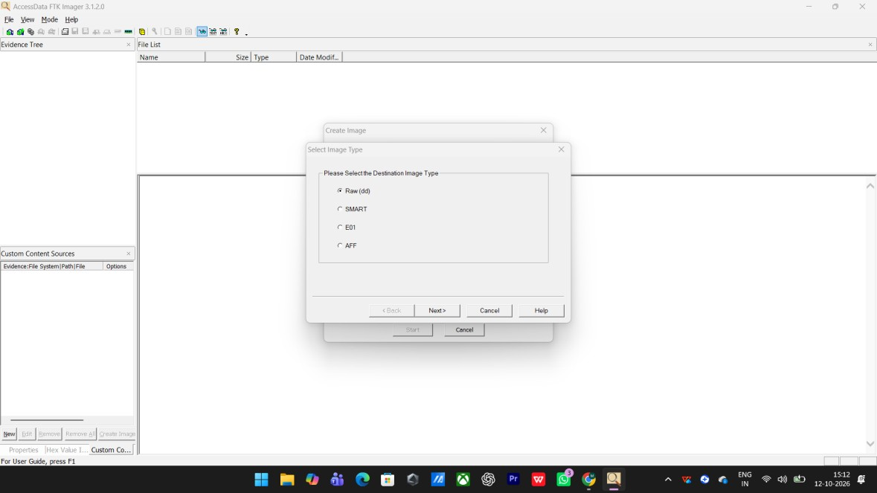
Fig. 5.4 FTK Imager – choosing the destination image type (Raw dd) Timestamp: 12-10-2026, 15:12:20
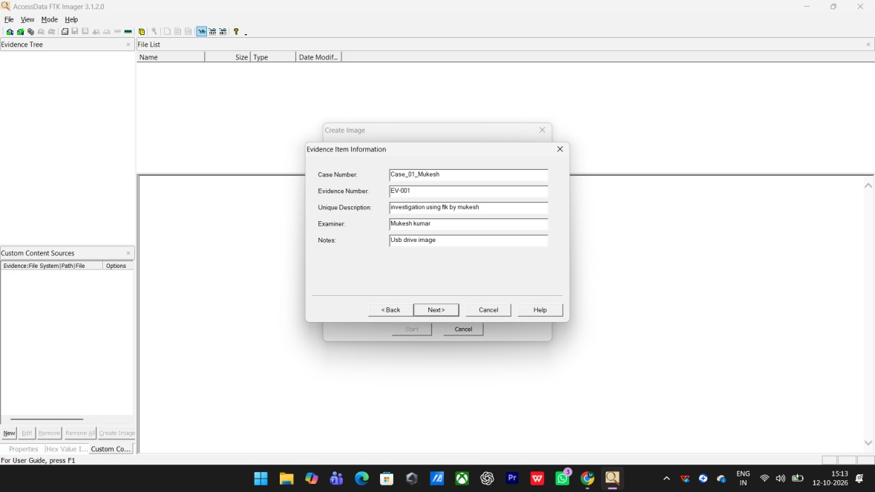
Fig. 5.5 FTK Imager – entering the evidence item information
Timestamp: 12-10-2026, 15:14:01
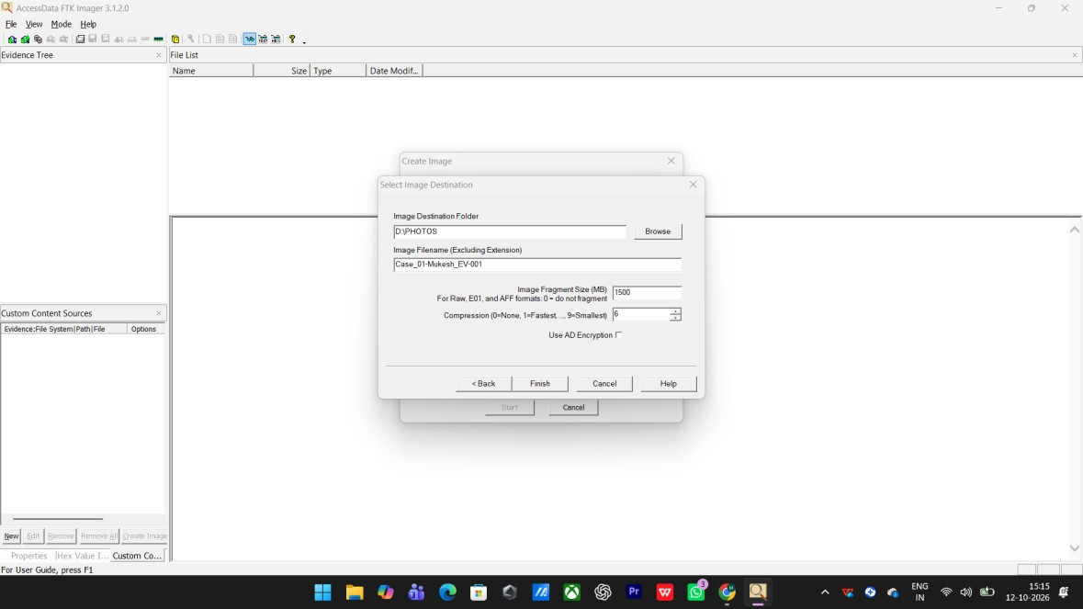
Fig. 5.6 FTK Imager – specifying the image destination folder and file name Timestamp: 12-10-2026, 15:15:06
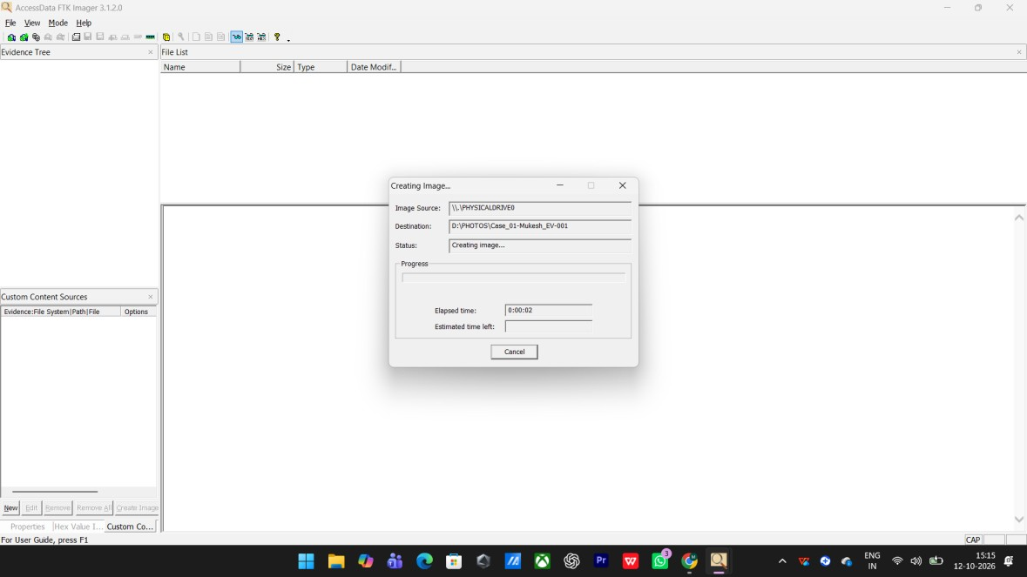
Fig. 5.7 FTK Imager – creating the bit-by-bit image of the drive
Timestamp: 12-10-2026, 15:15:25
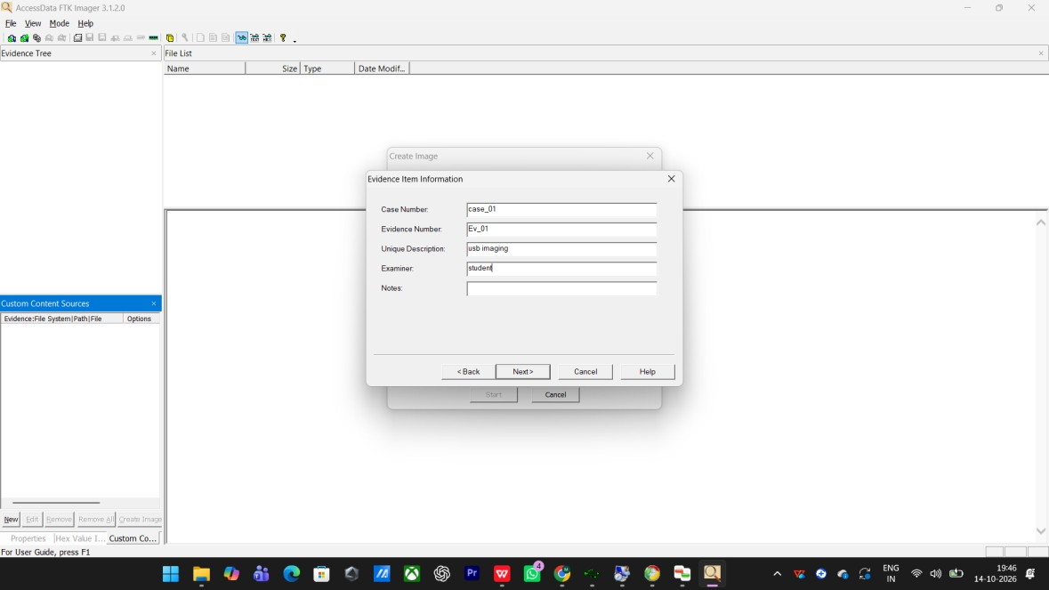
Fig. 5.8 FTK Imager – entering the evidence item information for the device image Timestamp: 14-10-2026, 19:46:44
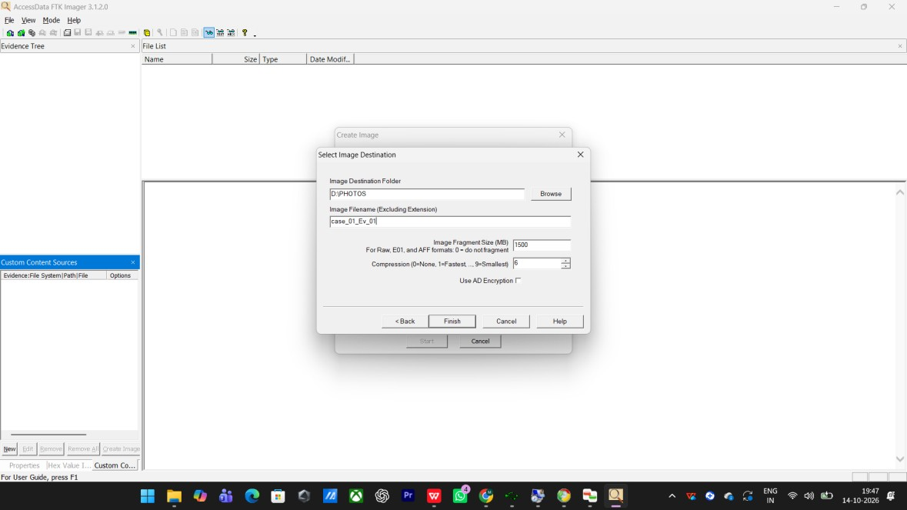
Fig. 5.9 FTK Imager – setting the image destination folder
Timestamp: 14-10-2026, 19:47:16
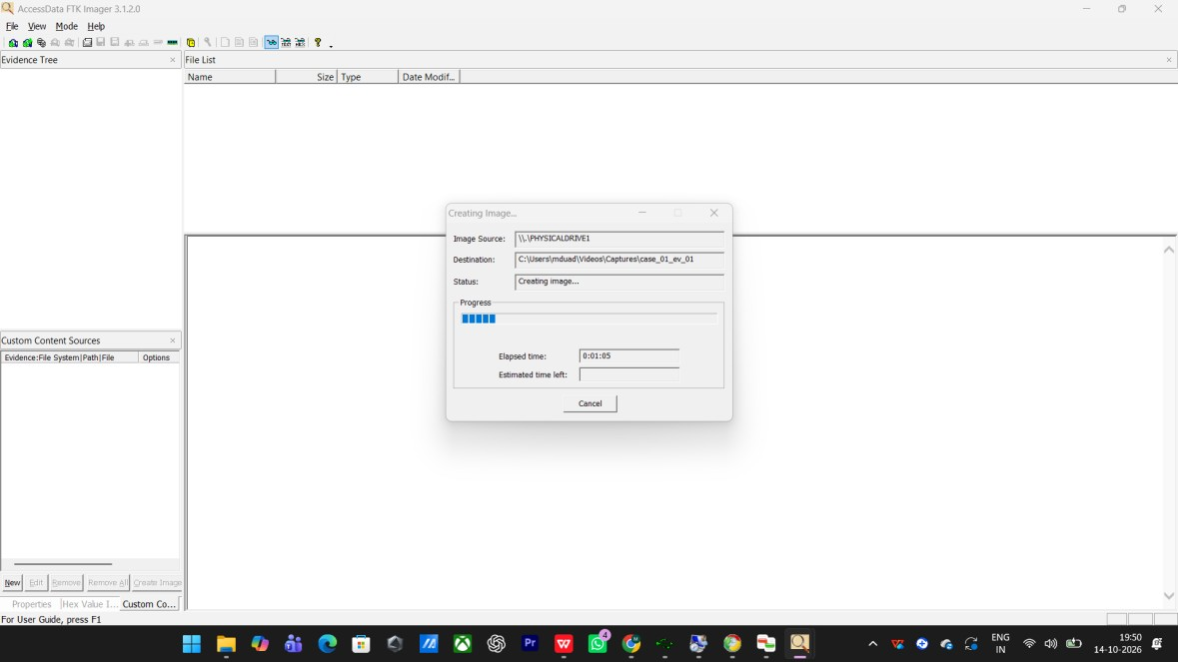
Fig. 5.10 FTK Imager – imaging the device (creating the image) Timestamp: 14-10-2026, 19:50:49
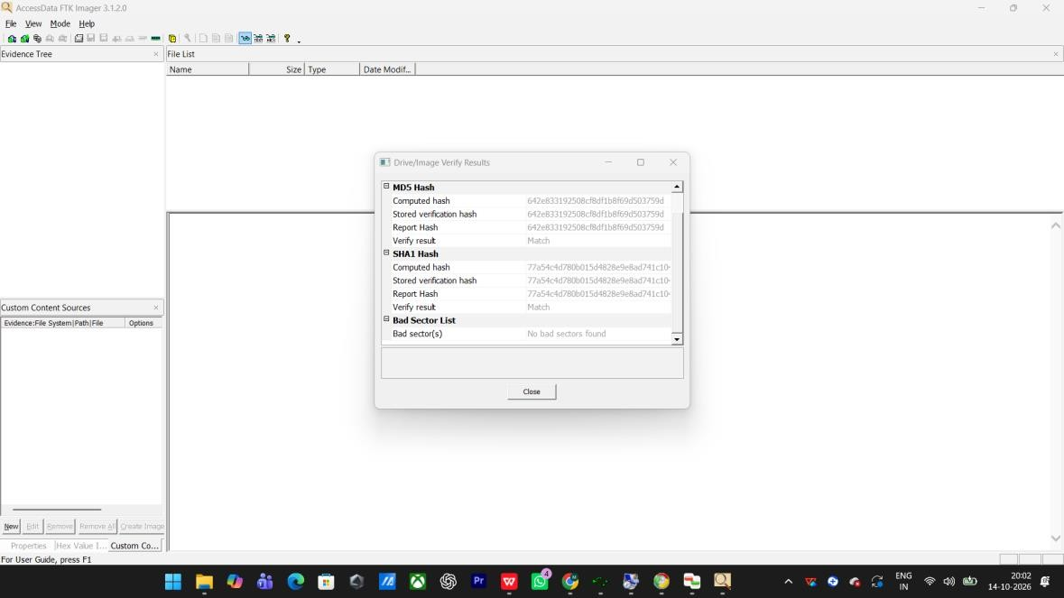
Fig. 5.11 FTK Imager – verifying the image (MD5 and SHA-1 hash values)
Timestamp: 14-10-2026, 20:02:58
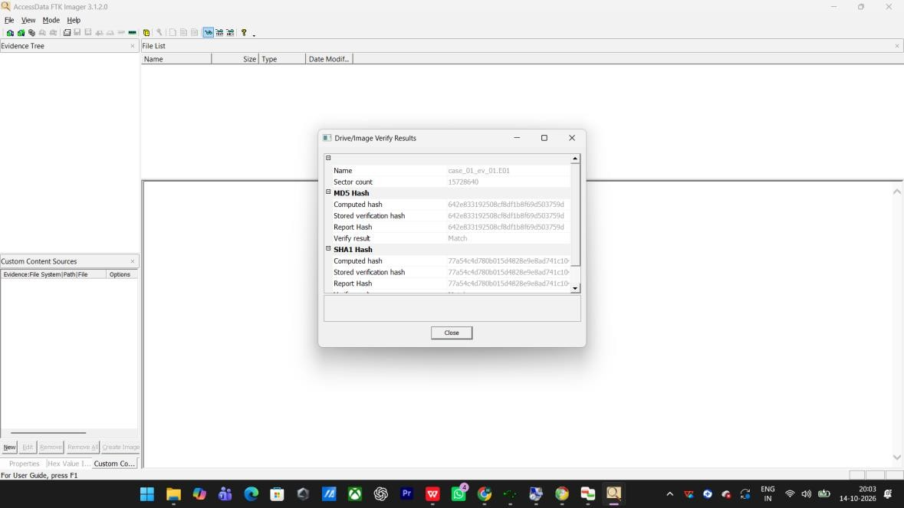
Fig. 5.12 FTK Imager – drive/image verification results Timestamp: 14-10-2026, 20:03:12
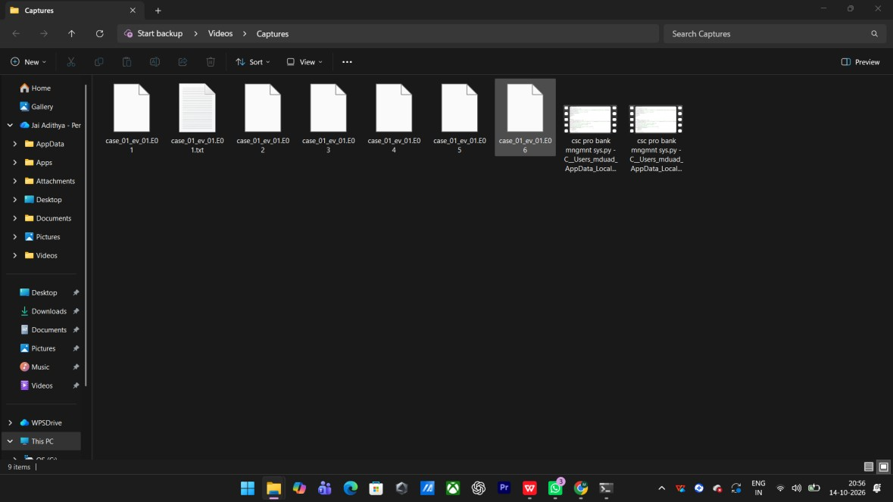
Fig. 5.13 The generated E01 image segments of the device
Timestamp: 14-10-2026, 20:56:41

Result
Thus, the deleted file was recovered using forensic tools. A bit-by-bit image of the device was created with FTK Imager, the integrity of the image was verified using the MD5 and SHA-1 hash values, and the deleted content was recovered and verified successfully.

EXPERIMENT -6
Find Last Connected USB on the System (USB Forensics)
To identify the last connected USB device on the system using USBDeview.

Procedure
- Download USBDeview (NirSoft) and run it on the system.
- The tool lists all USB devices that are currently connected to the computer, as well as all USB devices that were used previously.
- For each device observe the extended information – device name/description, device type, serial number (for mass storage devices), the Registry Time 1 and Registry Time 2 (the date and time the device was connected), VendorID and ProductID.
- Connect the USB flash drive and identify its entry in the list, for example ‘Mass Storage /
Generic Flash Disk USB Device’.
- Select the entry and view its properties to confirm the serial number, the drive letter and the last connected date and time.
- Record the device details as evidence. USBDeview can also be used to uninstall, enable, disable or disconnect USB devices and to work on a remote computer.
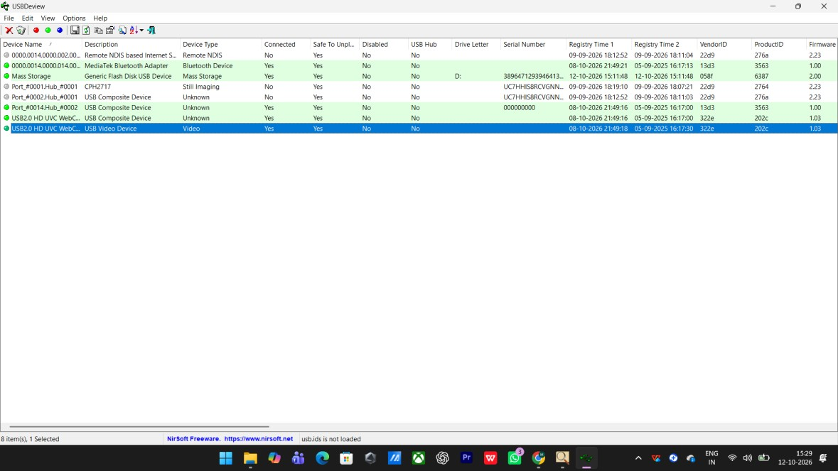
Fig. 6.1 USBDeview – list of connected and previously used USB devices
Timestamp: 12-10-2026, 15:29:06
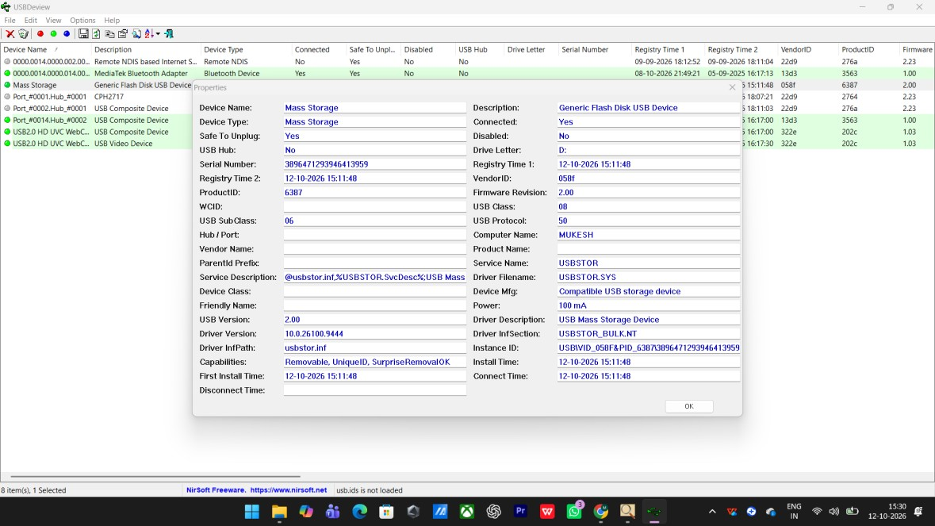
Fig. 6.2 USBDeview – properties of the last connected USB mass-storage device
Timestamp: 12-10-2026, 15:34:04

Result
Thus, the last connected USB device was identified using USBDeview. The device name, serial number, VendorID/ProductID and the last connected date and time were recorded as evidence.

EXPERIMENT 7
View Last Activity of Your PC
To view the last activity performed on the system using the LastActivityView tool.

Procedure
- Download and run LastActivityView (NirSoft).
- The tool collects information from various sources on a running system and displays a log of the actions made by the user and the events that occurred on the computer.
- Observe the columns displayed – Action Time, Description, Filename, Full Path, More Information, File Extension and Data Source.
- Review the list to identify the most recent processes executed and the files or folders that were opened (for example usbdeview.exe, lastactivityview.zip, chrome.exe).
- Right-click on any record and select ‘Properties’ to view the detailed information about that activity, such as the exact action time and the data source (Prefetch file, registry, etc.).
- Use the collected timeline of user actions and system events for forensic analysis.
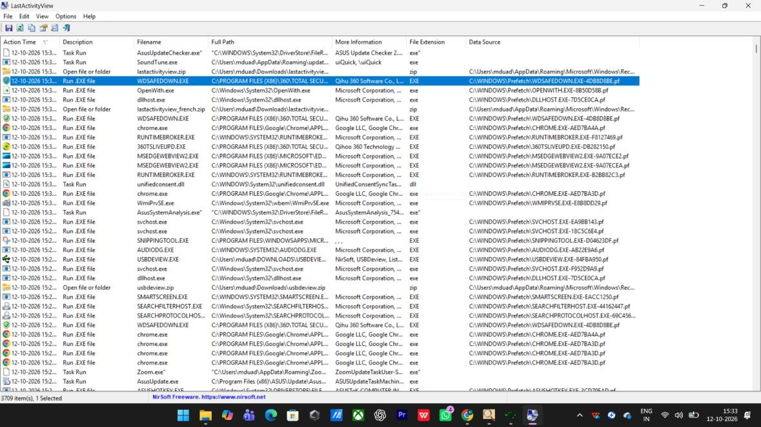
Fig. 7.1 LastActivityView – log of recent user actions and system events Timestamp: 12-10-2026, 15:33:52
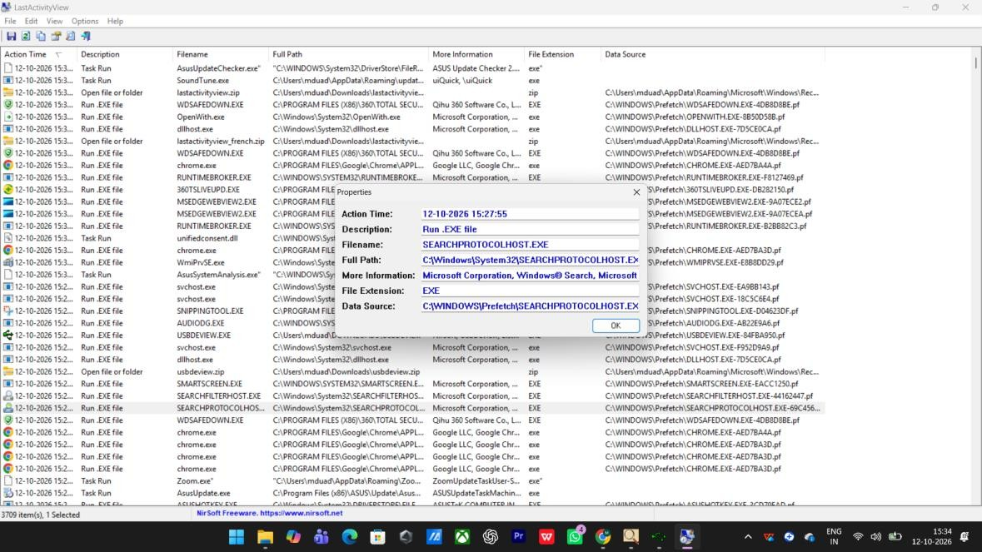
Fig. 7.2 LastActivityView – properties of a selected activity record
Timestamp: 12-10-2026, 15:34:23

Result
Thus, the last activities performed on the system were viewed successfully using LastActivityView, which provided a timeline of user actions and system events for forensic analysis.

EXPERIMENT 8
Extraction of Browser Artifacts
To extract browser artifacts such as the browsing history and cache from the system using browser forensic tools.

Procedure
- ChromeHistoryView is a small utility that reads the history data file of the Google Chrome web browser and displays the list of all the web pages visited in the last days.
- For each visited web page it displays the URL, title, visit date/time, number of visits, the number of times the address was typed (Typed Count), the referrer and the Visit ID.
- Run ChromeHistoryView and observe the list of visited pages.
- Use the ‘Find’ option to search for a keyword within the browsing history.
- Select a record to view its detailed properties such as the visit count, referrer and the path of the Chrome user-data folder.
- ChromeCacheView reads the cache folder of Google Chrome and displays the files stored in the cache (URL, content type, file size, last accessed time, etc.).
- IEHistoryView and IECacheView can be used in the same way to read the history and cache of Internet Explorer.
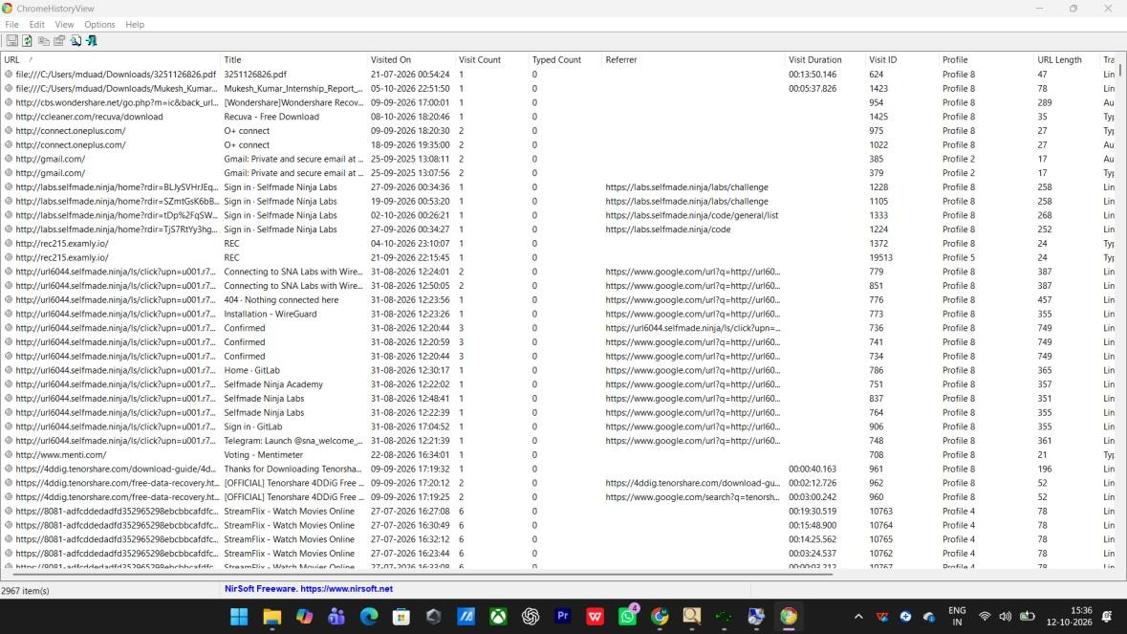
Fig. 8.1 ChromeHistoryView – history of visited web pages
Timestamp: 12-10-2026, 15:36:08
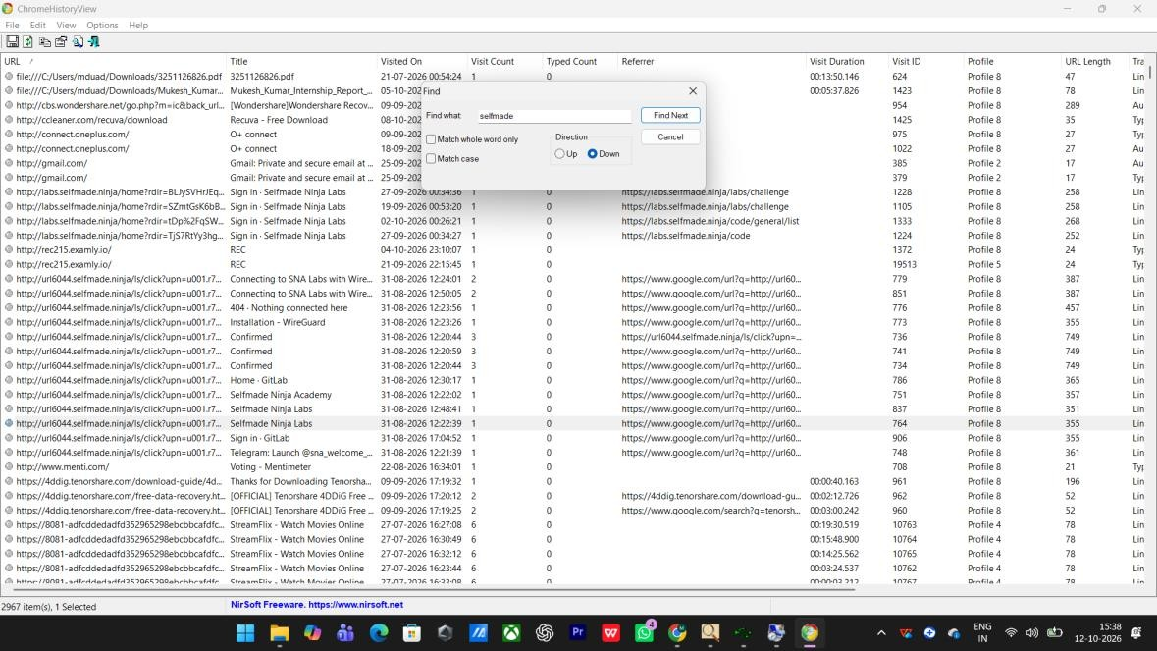
Fig. 8.2 ChromeHistoryView – searching the history for a keyword
Timestamp: 12-10-2026, 15:38:33
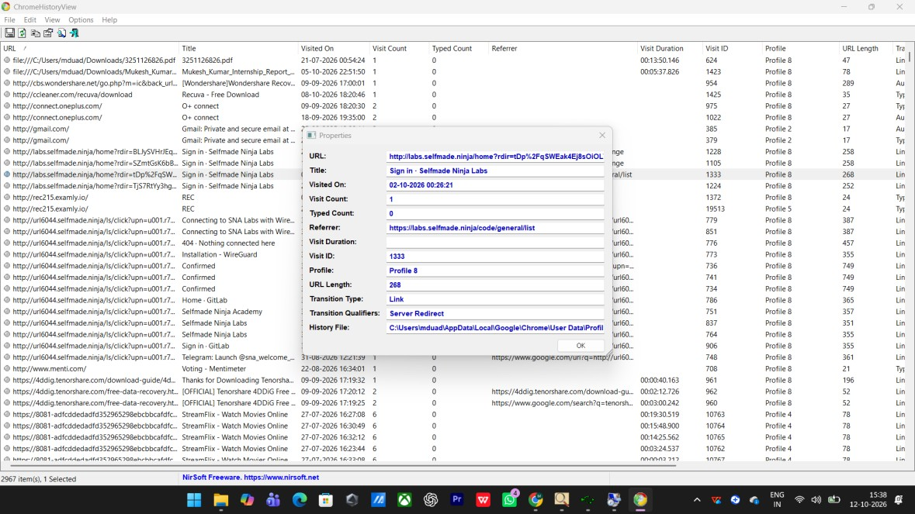
Fig. 8.3 ChromeHistoryView – details of a selected history entry
Timestamp: 12-10-2026, 15:38:46

Result :

Thus, the browser artifacts were extracted successfully. The list of visited web pages, along with the visit date/time, visit count and referrer, was obtained and can be used as evidence during a forensic investigation.

EXPERIMENT – 9
Comparison of Two Files by Compare It Software

Aim
To compare two files for forensic investigation using the Compare It software and to generate a differences report.

Procedure
- Install the Compare It software on the system.
- Compare It displays two files side by side with coloured difference sections that simplify the analysis.
- Click on the Compare It tool; a window opens to select the files to be compared.
- Select the first file and click ‘Open’, then select the second file and click ‘Open’.
- The tool displays the changes between the two files with highlighted bars; the changes can be moved between the files with a single mouse click or keystroke.
- The files can also be edited directly inside the comparison window.
- Generate a coloured printout / report of the differences exactly as shown on the screen.
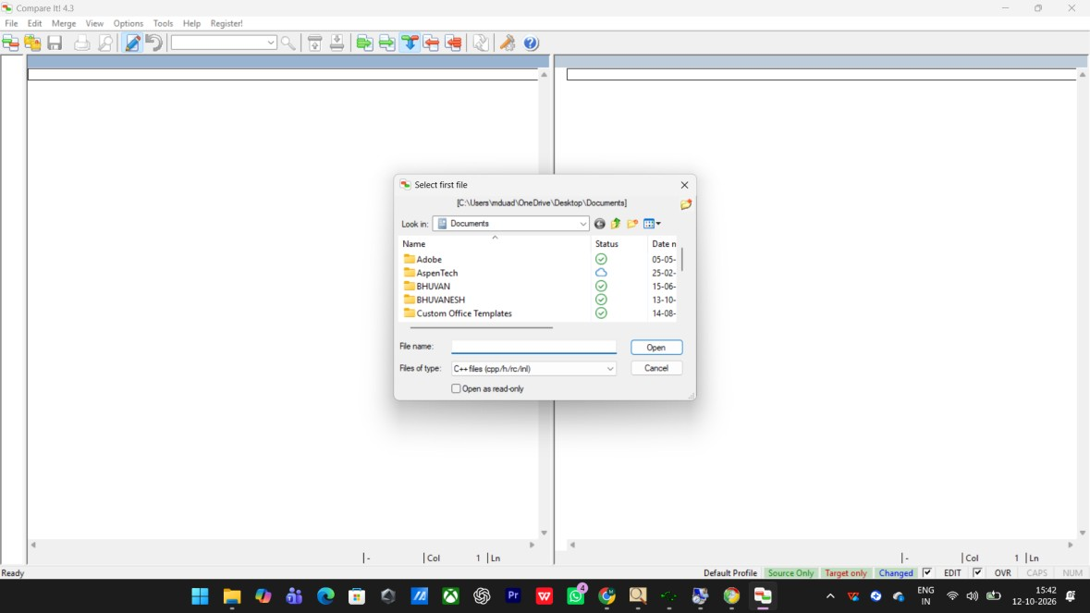
Fig. 9.1 Compare It – selecting the first file to compare Timestamp: 12-10-2026, 15:42:35
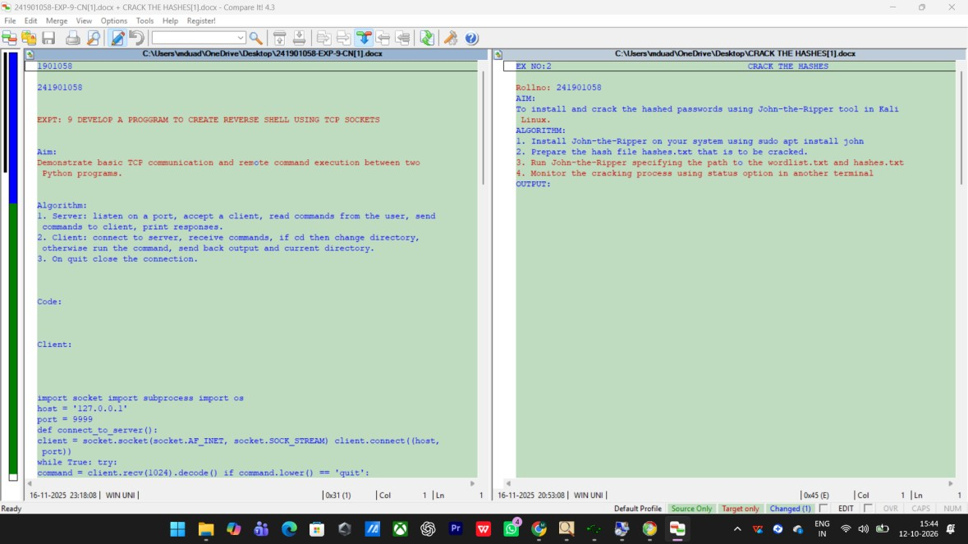
Fig. 9.2 Compare It – side-by-side comparison showing the differences between the two files
Timestamp: 12-10-2026, 15:44:17
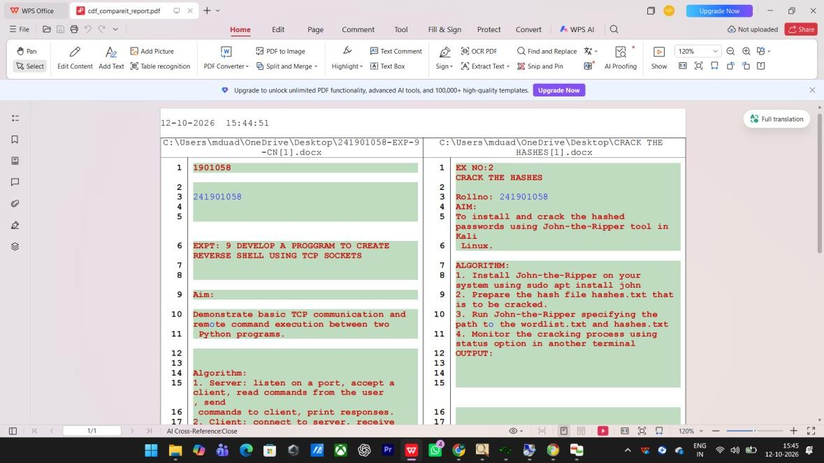
Fig. 9.3 Generated comparison report (cat_compareit_report.pdf)
Timestamp: 12-10-2026, 15:45:56

Result
Thus, the two files were compared successfully using Compare It. The differences between the files were highlighted and a detailed comparison report was generated for forensic investigation.

EXPERIMENT – 10
Collecting Email Evidence in Victim PC

Aim
To collect e-mail evidence from a victim’s PC by acquiring the physical memory and extracting the e-mail artifacts.

Procedure
- Memory acquisition: The first step in collecting e-mail evidence from the victim’s PC is to capture the victim’s RAM using the DumpIt tool.
- DumpIt is a utility that generates a physical memory dump of Windows machines; it works on both x86 (32-bit) and x64 (64-bit) systems and is perfect to deploy on a USB key for quick incident response.
- Run dumpit.exe. The destination path of the raw memory dump is displayed and a confirmation question is prompted.
- Type ‘Y’ and press Enter to proceed; the raw memory dump (.raw / memory dump) is generated and saved in the same directory.
- Feature extraction: Download and install the Bulk Extractor Viewer from GitHub.
- Open Bulk Extractor Viewer and click to generate a report; select the DumpIt memory image as the input and choose an output folder for the report, then click ‘Start’.
- Bulk Extractor scans the memory image and writes its output into several feature files such as email.txt, email_histogram.txt, url.txt, telephone.txt, etc.
- Open email.txt to inspect the e-mail addresses saved in the victim system, and open email_histogram.txt to view how often each address occurs.
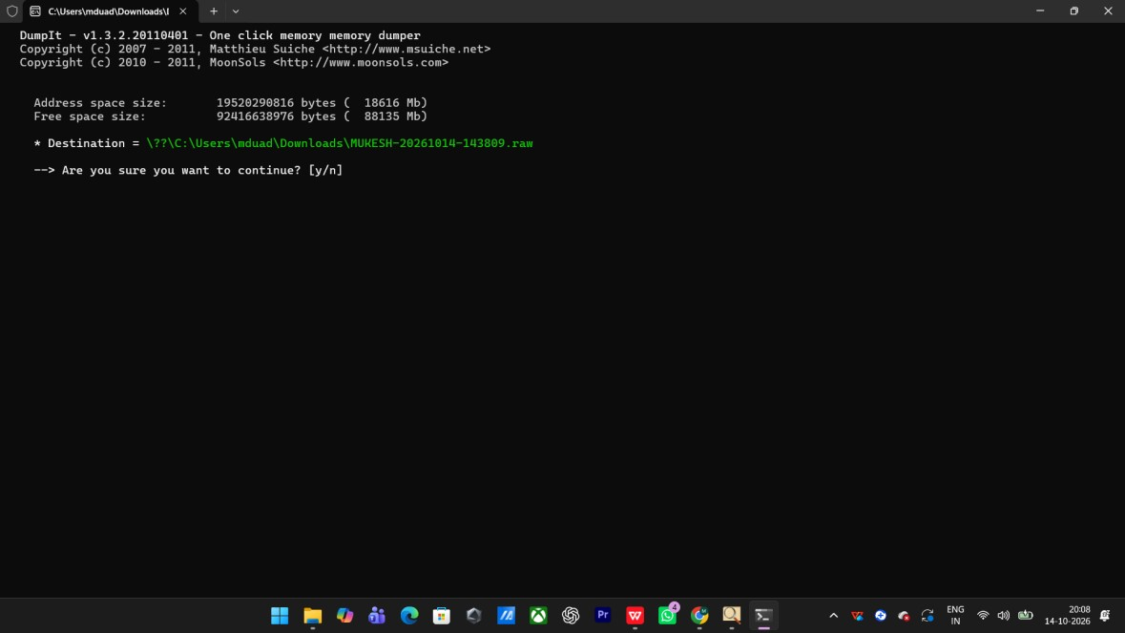
Fig. 10.1 DumpIt – acquiring a raw physical memory dump
Timestamp: 13-10-2026, 15:12:41
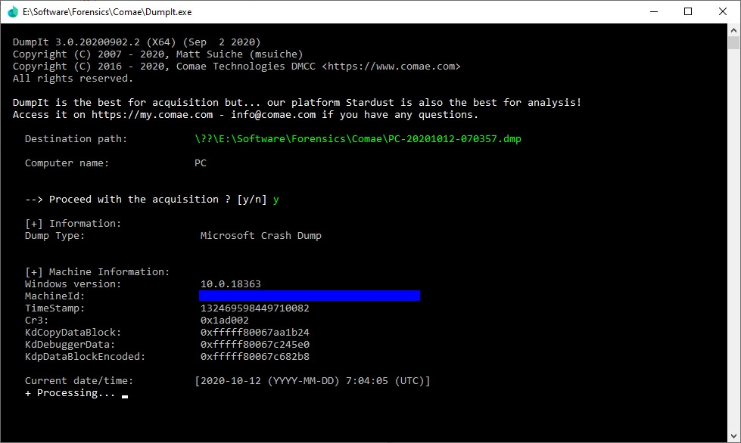
Fig. 10.2 DumpIt – memory acquisition in progress Timestamp: 13-10-2026, 15:18:07
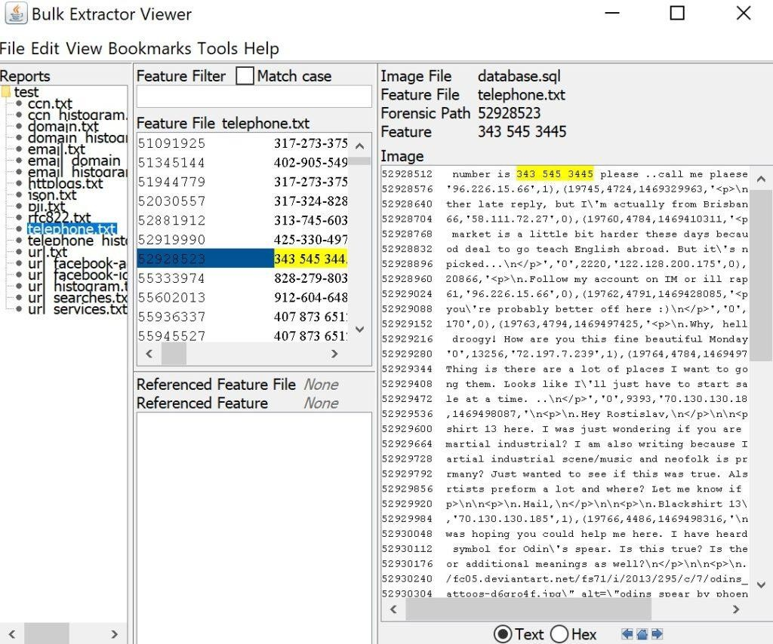
Fig. 10.3 Bulk Extractor Viewer – extracted feature files from the memory image Timestamp: 13-10-2026, 15:36:28
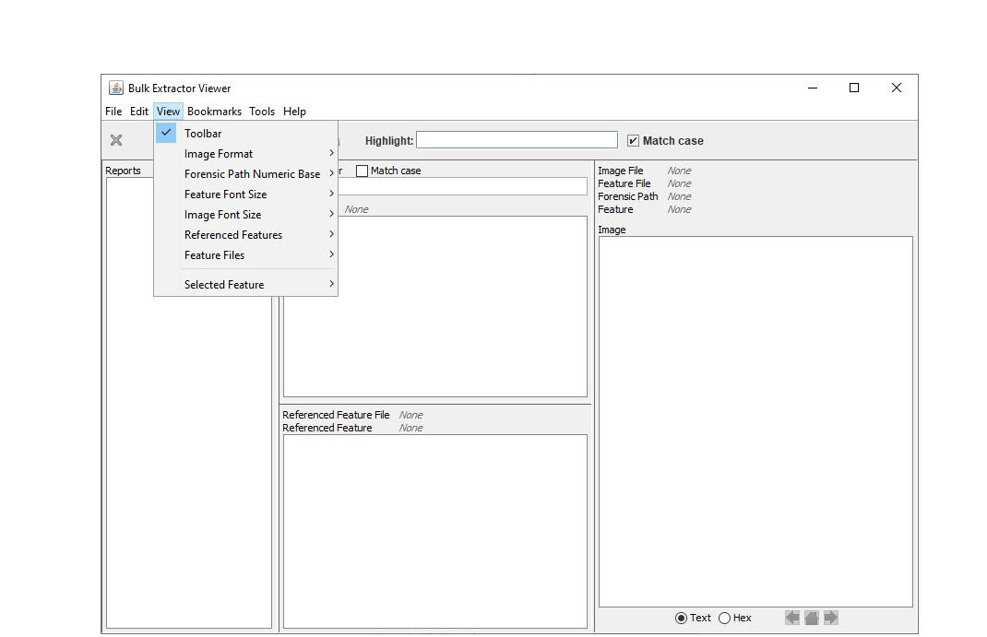
Fig. 10.4 Bulk Extractor Viewer – viewing the extracted features
Timestamp: 13-10-2026, 15:41:55

Result
Thus, the e-mail evidence from the victim’s PC was collected successfully. The physical memory of the victim system was acquired using DumpIt, the memory image was processed with Bulk Extractor, and the e-mail addresses and their histogram were extracted and examined.

EXPERIMENT – 11
Hiding and Extracting a Text File behind an Image / Audio File using Command Prompt

Aim
To study the steps for hiding and extracting any text file behind an image file or an audio file using the Command Prompt.

Procedure
- Hiding the text file in an image: Any file such as .rar, .jpg or .txt can be merged inside another file. Using the Command Prompt, a text file can be hidden inside an image file.
- Copy the file to be hidden (for example sample.txt) and the carrier image (for example sample1.jpg) into the same folder.
- Open the Command Prompt (Ctrl+R → cmd) and navigate to that folder using the cd command.
- Merge the two files with the binary copy command: copy /b sample1.jpg + sample.txt result.jpg
- The image file and the text file are combined into the output file result.jpg, which still opens as a normal image file.
- Extracting the hidden file: To retrieve the hidden data, locate result.jpg, right-click it and open it with Notepad – the hidden content is found at the end of the file.
- Hiding a RAR archive: In the same way a RAR archive can be hidden behind an image: copy /b sample1.jpg + sample.rar result.jpg, and the archive is opened by opening result.jpg with WinRAR.
- Hiding a ZIP in an audio file: A ZIP archive can be hidden behind an audio file: copy /b sound.mp3 + new.zip newfile.mp3. The data is recovered either by changing the extension from .mp3 to .zip or by opening newfile.mp3 with a ZIP program.
- On Linux the same merge can be performed with: cat sound.mp3 secret.zip > newfile.mp3
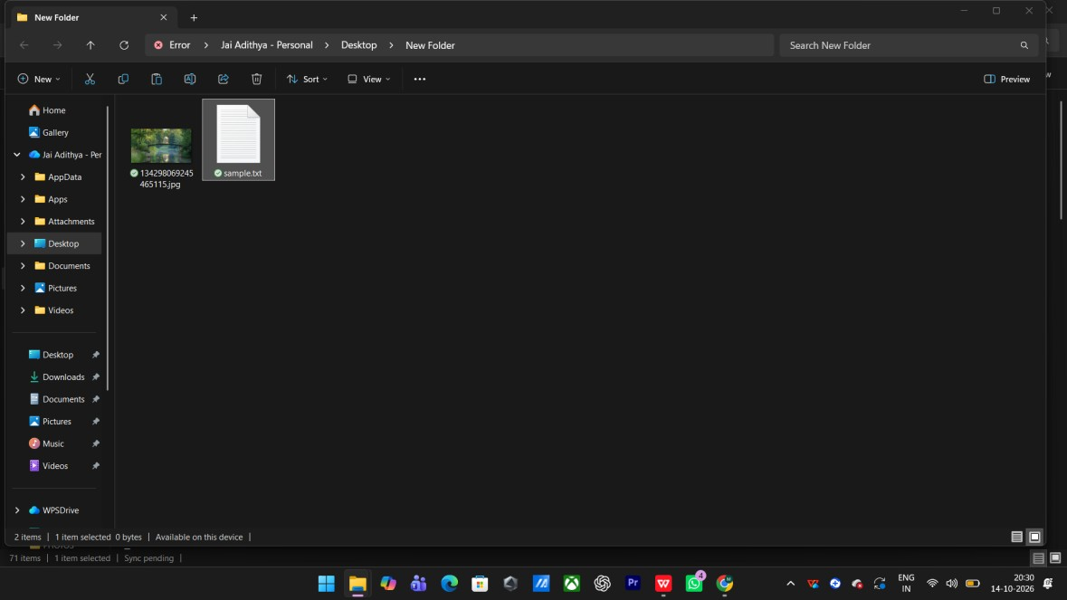
Fig. 11.1 Placing the text file and the carrier image in a folder
Timestamp: 14-10-2026, 20:30:41
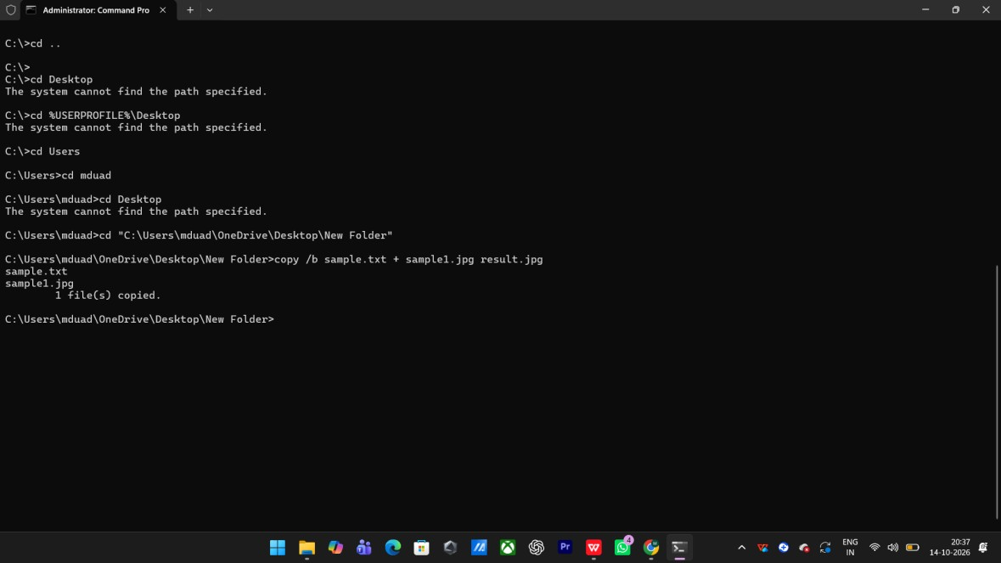
Fig. 11.2 Command Prompt – merging the text file with the image (copy /b) Timestamp: 14-10-2026, 20:37:19
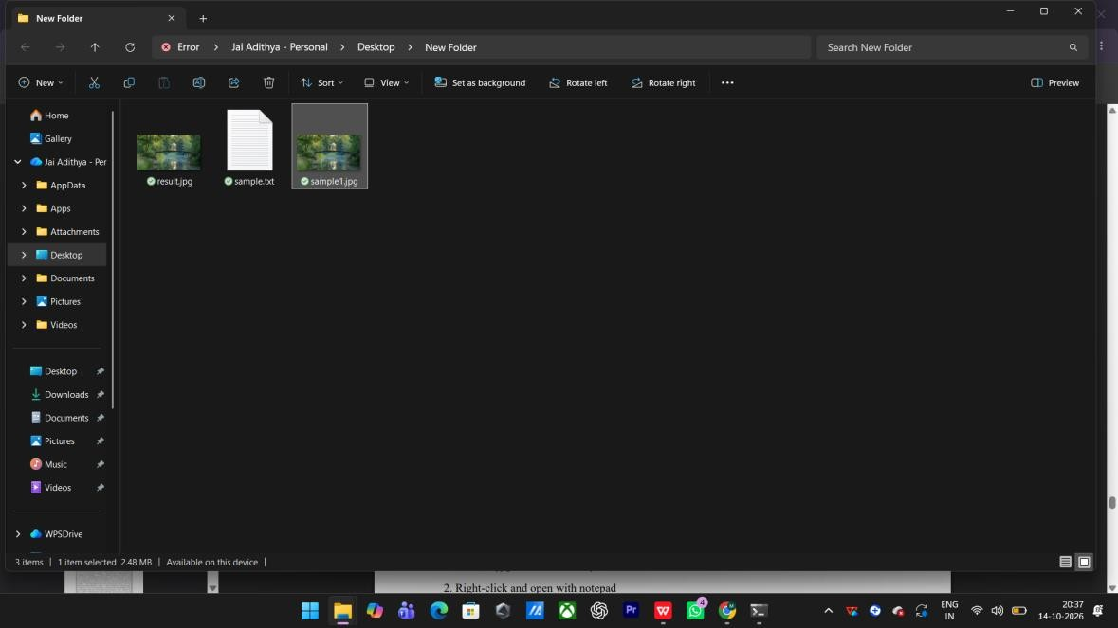
Fig. 11.3 The output image result.jpg generated after the merge
Timestamp: 14-10-2026, 20:37:39
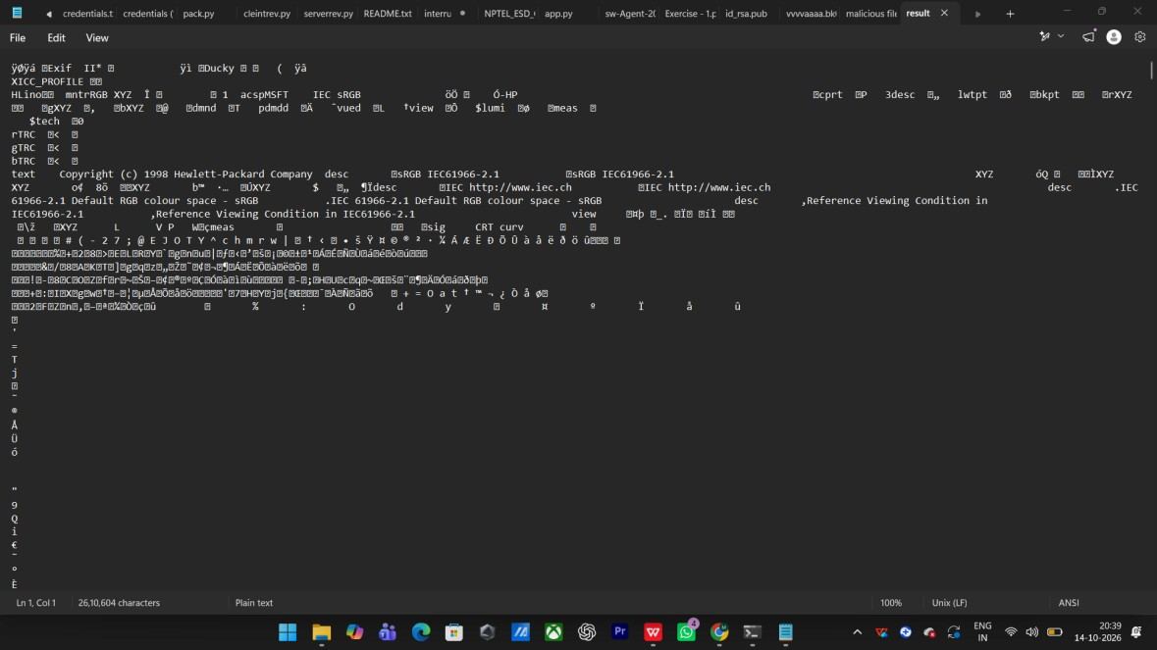
Fig. 11.4 Opening result.jpg with Notepad to retrieve the hidden text Timestamp: 14-10-2026, 20:39:23
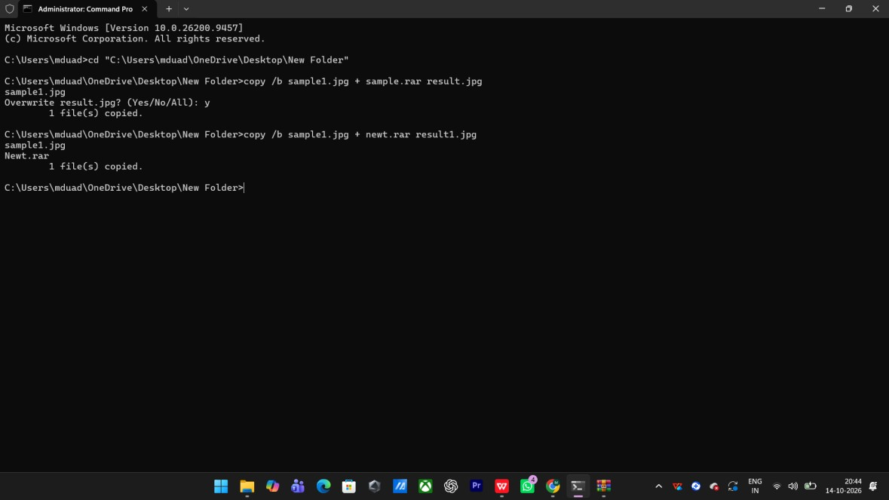
Fig. 11.5 Command Prompt – hiding a RAR archive behind the image
Timestamp: 14-10-2026, 20:44:24
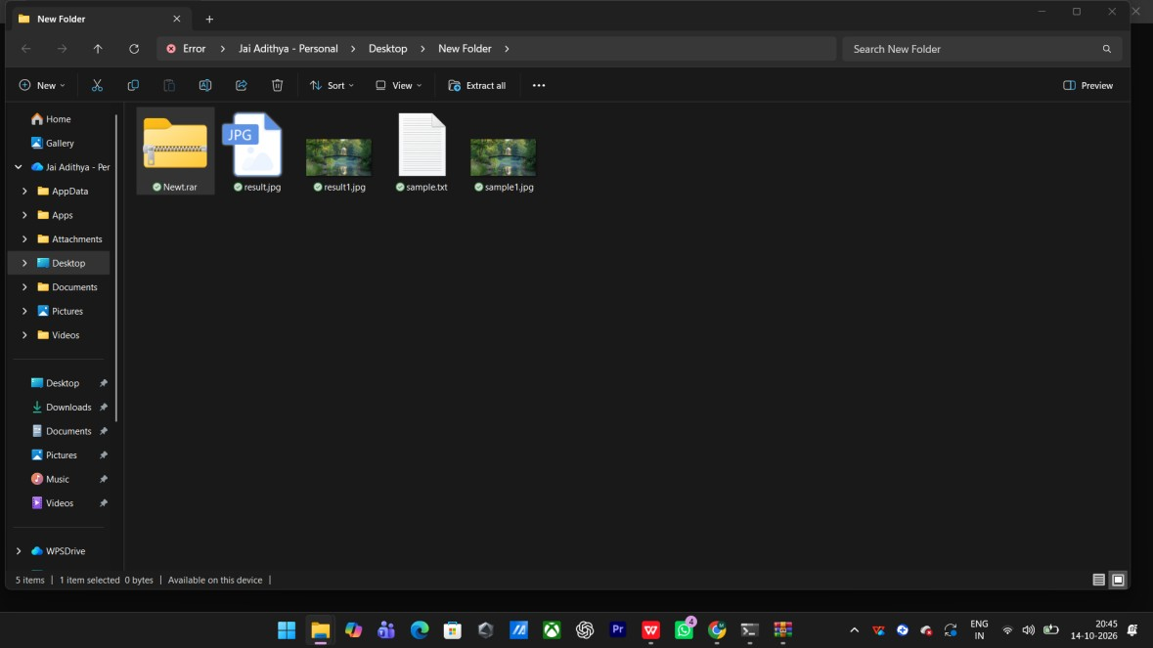
Fig. 11.6 The output image containing the hidden RAR archive Timestamp: 14-10-2026, 20:45:23
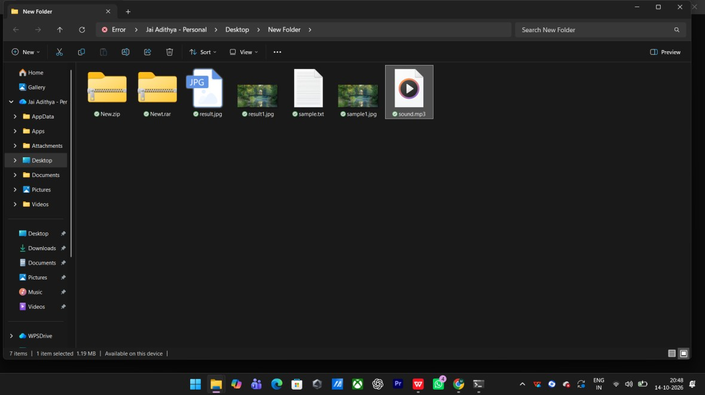
Fig. 11.7 Files prepared for hiding data behind an audio file
Timestamp: 14-10-2026, 20:48:55
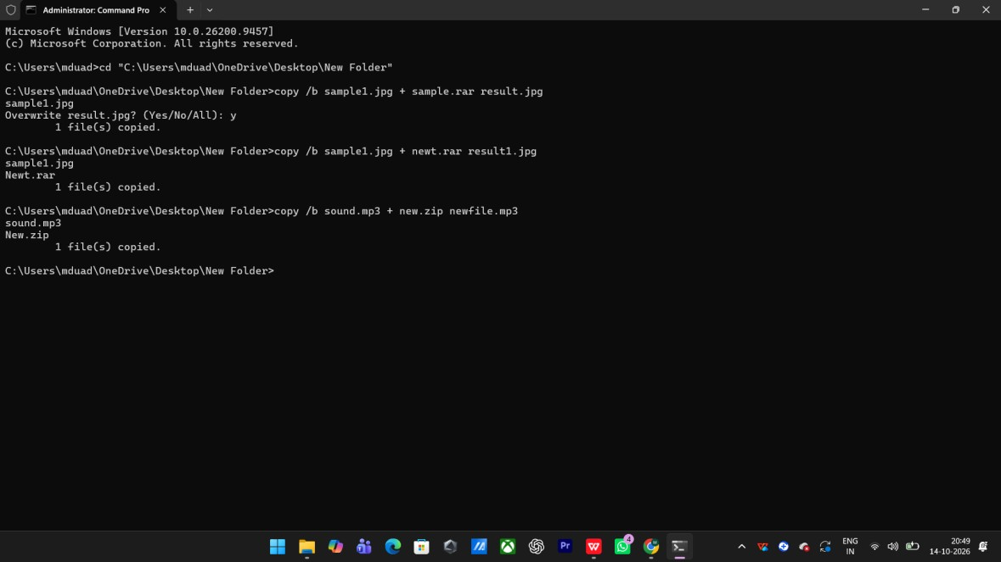
Fig. 11.8 Command Prompt – merging the ZIP archive with the audio file Timestamp: 14-10-2026, 20:49:31
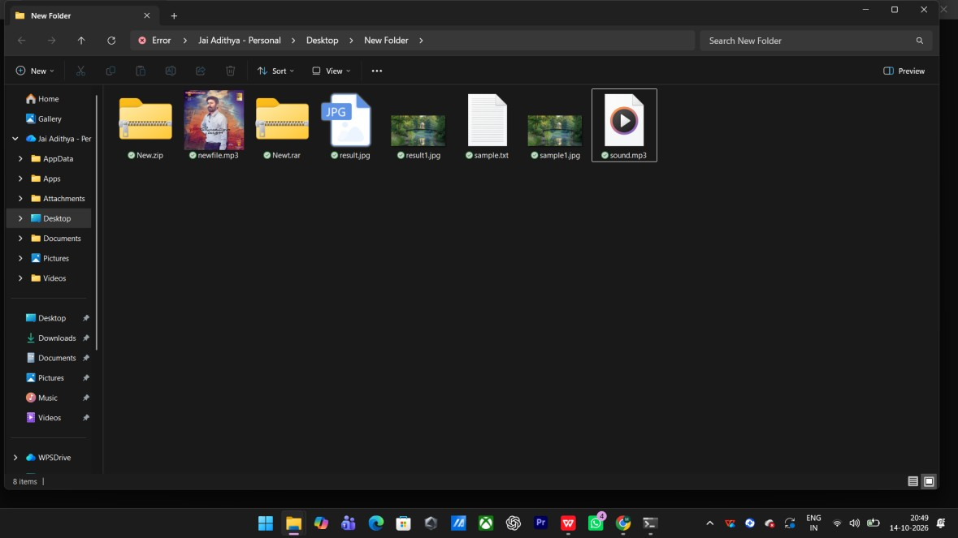
Fig. 11.9 The output audio file newfile.mp3 containing the hidden ZIP archive
Timestamp: 14-10-2026, 20:49:43

Result
Thus, a text file, a RAR archive and a ZIP archive were hidden behind an image file and an audio file using the Command Prompt, and the hidden content was retrieved successfully.
The output files continued to open normally as image and audio files.

EXPERIMENT – 12
Extraction of EXIF Data from Image Files using ExifReader

Aim
To extract the Exchangeable image file format (EXIF) data from an image file using the ExifReader software.

Introduction
When a computer, phone or mobile device is seized for evidence, the system usually contains graphic images that may be used as evidence. Most digital devices ‘stamp’ information on these images that can tell us about the who, what, when and where of the picture. This information is known as EXIF data and is often useful to the forensic investigator.
EXIF is a standard set by the digital camera industry to identify formats for digital images and sound files. It includes camera settings, time, date, shutter speed, exposure, whether a flash was used, compression, the name of the camera and other information. Several applications can extract this data; for this experiment a simple Windows-based tool called ExifReader is used.

Procedure
- Download ExifReader and run the file ExifRead.exe. It opens a clean and simple GUI wizard.
- Click on the ‘Open’ button and browse to the picture stored on the system or media. JPEG and JPG files normally contain the maximum information.
- Once the selected picture opens, it is loaded as a thumbnail on the left and the EXIF data is displayed on the right.
- Study the extracted information such as the Make and Model of the camera, DateTime, DateTimeOriginal, Exposure Time, FNumber, Exposure Program, ISO Speed Ratings, Compressed Bits, Focal Length, Flash and the GPS location.
- Note the details that are relevant to the investigation, as EXIF data can reveal when and where an image was captured and with which device.
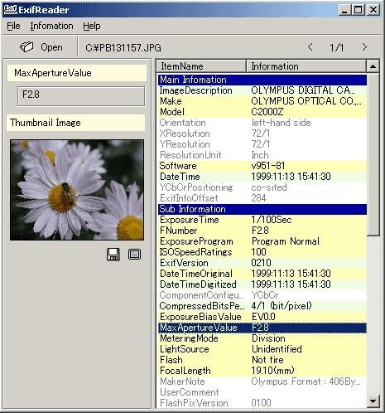
Fig. 12.1 ExifReader – EXIF metadata extracted from a JPEG image
Timestamp: 13-10-2026, 16:05:39

Result
Thus, the EXIF data was extracted successfully from the image file using the ExifReader software. The camera make and model, the date and time the picture was taken and the photographic settings were obtained, which can help the forensic investigator to link the image to its source.

